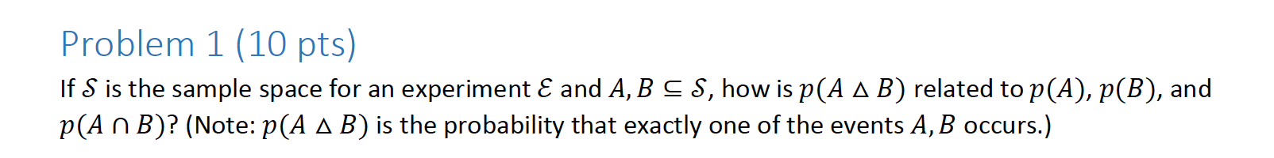

The probability that only one of the events occurs is either the P(A) – P(B not occurring) or P(B) – P(A not occurring). Thus, you can add these two together. And the probability of an event not occurring is just 1 – the probability of it occurring. However, due to the Inclusion Exclusion Principle, you must subtract out where A and B intersect to prevent from double counting.

P(A) – (1-P(B)) + P(B) – (1-P(A)) - p(A∩B)

P(A) – 1 + P(B) + P(B) – 1 + P(A) – P(A∩B)

P(A) + P(B) - 2 – P(A ∩ B)

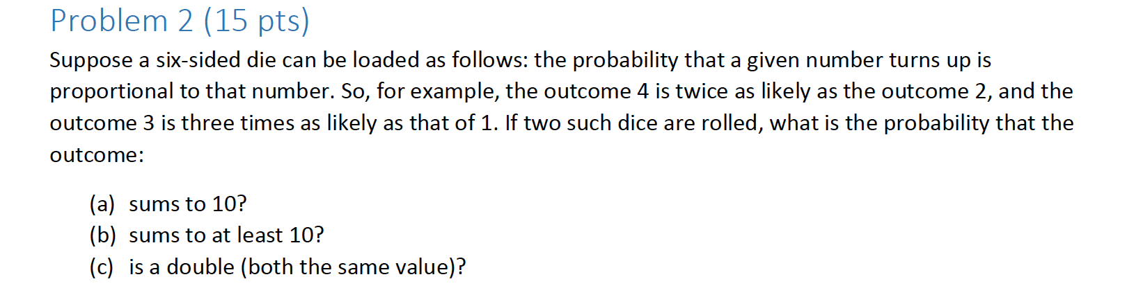

There are exactly three ways to get a sum of 10, out of 36 possible scenarios. You could get a 5 and a 5, a 4 and a 6, or a 6 and a 4.

That means that if you get a 10, that’s 5 times more likely than getting a sum of two.

And there are only six numbers, so their probability must add up to 1.

P(1) + P(2) + P(3) + P(4) + P(5) + P(6) = 1

And we know the probability of getting a 2 is twice as likely and so on.

X = P(1)

X + 2x + 3x + 4x + 5x + 6x = 1

21x = 1

x = 1/21

Now, we can just add the individual probabilities of getting a 5 and a 5, a 4 and a 6 and a 6 and a 4.

P(4) = 4/21

P(5) = 5/21

P(6) = 6/21

P(4)P(6) + P(5)P(5) + P(6)P(4) = Our result

2(4/21 (6/21)) + (5/21)(5/21)

= 0.1088435 + 0.05689

P(S=10) = **0.16548**

1. Sums to at least 10.

This means your possibilities are as follows:

5 5, 4 6, 6 4, 5 6, 6 5, 6 6

So P(Getting at least 10) = 2(5/21) + 2(4/21)(6/21) + 2(5/21)(6/21) + (6/21)(6/21)

0.16548 + 0.136 + 0.081632

= **0.3831**

1. Since they must be the same value, we can just sum all the probabilities together.

P(1)P(1) + P(2)P(2) + P(3)P(3) + P(4)P(4) + P(5)P(5) + P(6)P(6) =

1 / 441 + 4 / 441 + 9 / 441 + 16 / 441 + 25 / 441 + 36 / 441 =

91 / 441 = **0.2063**

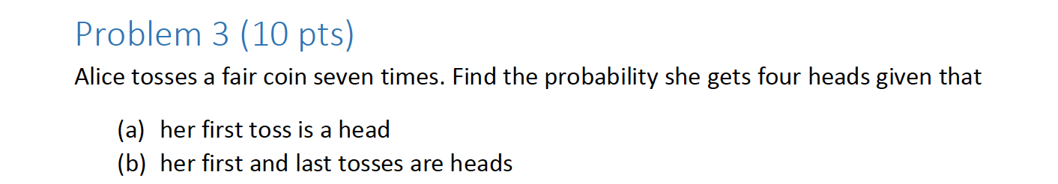

1. So if she gets one head, you have the following spaces.

H _ _ _ _ _ _. This means there are six spaces she could get a head. But she only needs a total of four, three more. Since there’s a 50/50 chance of getting a head versus a tail, her probability of flipping the coin and getting a head each time is ½.

There are (63) ways of placing three heads = 20 ways.

Multiplied by the probability of getting three heads and getting three tails.

20 * (1/2)^3 * (1/2)^3

= 20*(1/2)^6 =

**0.3125**

b.

So if she gets one head for the first and last toss, the board looks like this:

H _ _ _ _ _ H.

Which means she only needs to get two heads, and exactly three tails.

There are (52) ways of placing these heads.

So the answer becomes 5!/2!3! = 20/2 = 10 ways.

Since the probability I get a head is ½, and same for tails, I just multiply by ½ for each time I need a head or a tail.

10 * (1/2)^3 * (1/2)^2 = **0.3125**

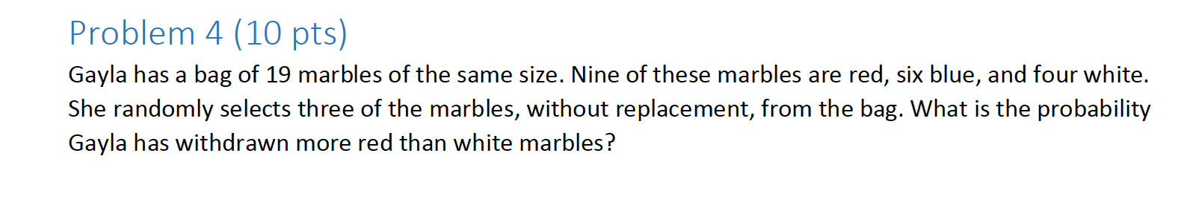

9 RED, 6 BLUE, 4 WHITE, TOTAL OF 19.

In order to withdraw more red than white marbles, Gayla has a few options. She could pick one red and two blues, or two red and one blue, or three red.

There are a total of 27 possible combinations of choosing marbles. Out of those 27, there are 9 ways she could get more red than blue.

RRB

RRW Thus, her total probability is 9 / 27 = **0.333333**

BRR

WRR

RRR

RRB

RBB

BRR

BBR

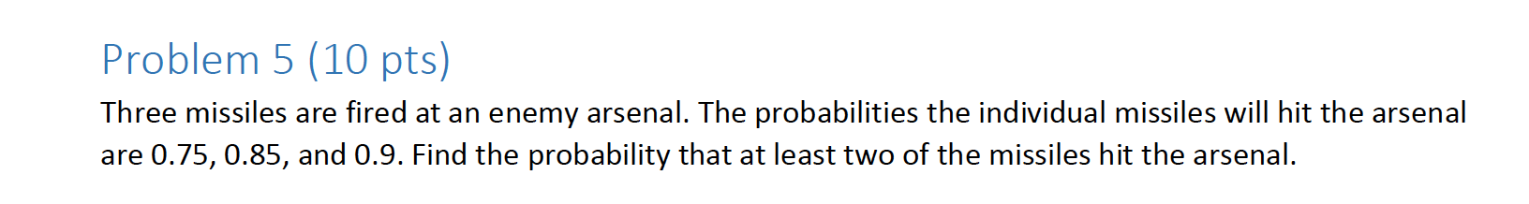

To get the probability of at least 2, I can subtract 1 from the probability of getting 0 and getting exactly 1.

So that’s 1-(P(0) + P(1)).

P(0) = Probability of getting none = (1-0.75) + (1-0.85)+(1-0.9) = 0.5.

P(1) = (0.75 * (1-0.85) * (1-0.9)) + (0.85 * (1-0.75) * (1-0.9)) + (0.9 * (1-0.75) * (1-0.85) = 0.06625

1-(0.5 + 0.06625) =

**0.43375**

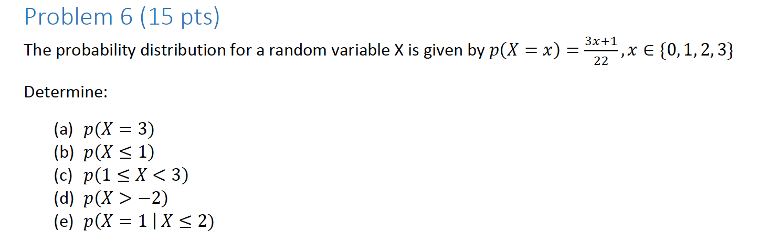

A.

Just plug in 3. P(X = 3) = 3(3) + 1 / 22 = 10 / 22 = **0.4545**

B.

Since X can only be the values 0, 1, 2, and 3, only two of those values are less than or equal to 1.

So get the P(0) and add it to P(1) to get the probability of either.

P(x=0) = 1/22

P(x = 1) = 4/22

Total = 5/22 = **0.227**

C. X must be greater or equal to 1 but less than three. Well, then x is either 1, or 2.

So add P(1) + P(2).

P(x = 1) = 4/22

P(x = 2) = 7/22

Total: 11 / 22 = **0.5**

D. Since x must be greater than -2, than means you add the probabilities of the entire set.

P(x=0) + P(x = 1) + P(x=2) + P(x=3)

=

1/22 + 4/22 + 7/22 + 10/22 = 22/22 = 1.

Intuitively, this makes sense because we have selected the entire set, so of course we will have a probability of 1.

E. So we must calculate the P(x = 1) or P(x <=2)

This means we can add the two probabilities together.

We know that the P(x<= 2) encompasses three numbers: 0, 1, and 2.

So we know P(x <=2) = P(0) + P(1) + P(2) = 12/22 = 0.54545.

Since we’ve already included P(x = 1), we don’t want to double count it, and our answer is **0.54545**

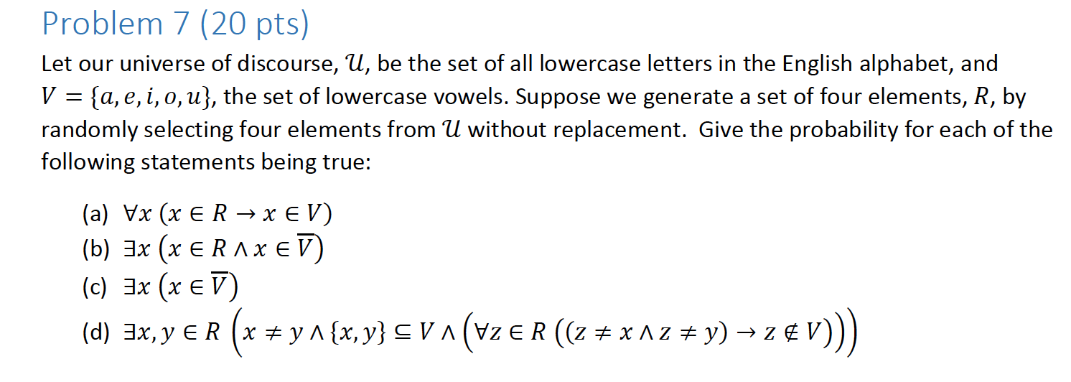

Selecting 4 elements…

A.

The first one translates to “Each letter chosen means that each letter is a vowel.”

Since there are only 5 vowels in the alphabet, the probability this is true is 5/26 = 0.1923, for each letter chosen. If you choose 4 elements, in order for them all to be vowels, you must multiply the probabilities together.

(0.1923)4 = **0.00136746788**

B.

“There exists a value of x such that x is a letter and not a vowel.”

Which means we are choosing four letters, and at least one of them must be a consonant. Well, we know there are 21 consonants. And the probability of getting a consonant = 21 / 26 = 0.807692 for each letter drawn. Since we are choosing four, as long as we have at least one consonant, it does not matter whether the other three are a vowel or consonant.

So our answer is 0.8076(1)(1)(1) = **0.8076**

C.

X and Y are two unique vowels, and For each of the four elements, and Z is a consonant.

Since there will always exist a letter that is a vowel, the answer is **1**.

D.

X and Y are two unique vowels, and Z is a consonant.

The probability of getting two vowels and a consonant when you choose three out of four is:

(43) (5/26)(5/26)(21/26) =

4(5/26) (5/26)(21/26)

= **0.1194811106**

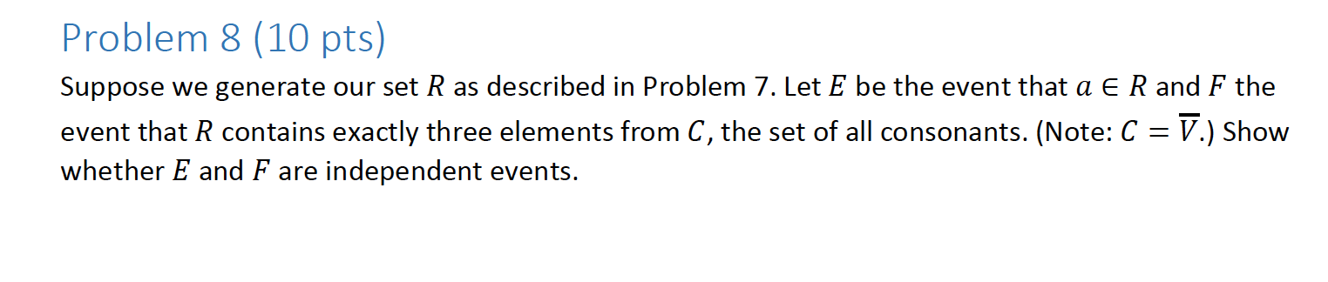

E = choose four

F = R contains exactly three consonants.

P(E) = 4/26 = 0.15384615384

Probability of three consonants times one vowel:

P(F) = (21/26)^3 * (5/26) = 0.10132917264

P(E∩F) = 4/26 (0.101329) = 0.01558907692

P(E|F) = P(E∩F)P(E) / P(F)

P(E | F) = (0.01558907692)(4/26) / 0.10132917264 = 0.02366859872.

Since P(E | F) is not equal to the P(E), the events are dependent on each other.

Bayes Theorem:

P(E | F) P (F)

P(F|E) = ----------------

P(E|F)P(F) + P(E | ¬F)P(¬F)